[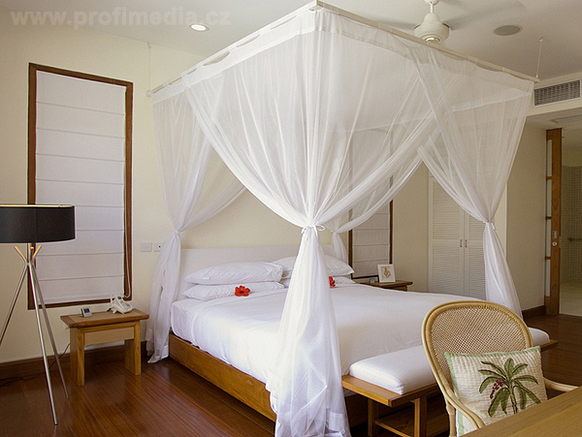](http://www.google.cz/url?sa=i&source=images&cd=&cad=rja&docid=V6HySZWDkSegTM&tbnid=vK3uY8WddlbgBM:&ved=0CAgQjRwwAA&url=http://test.viaweb.cz/interier-inspirovany-romantickym-stylem-bydleni-nejen-pro-romantiky-20268.aspx&ei=wZ6wUdukJqSk4ATQuYDoAw&psig=AFQjCNEeczD1bz6bAza-DwBCXiMoWJxEHg&ust=1370615873666933)

[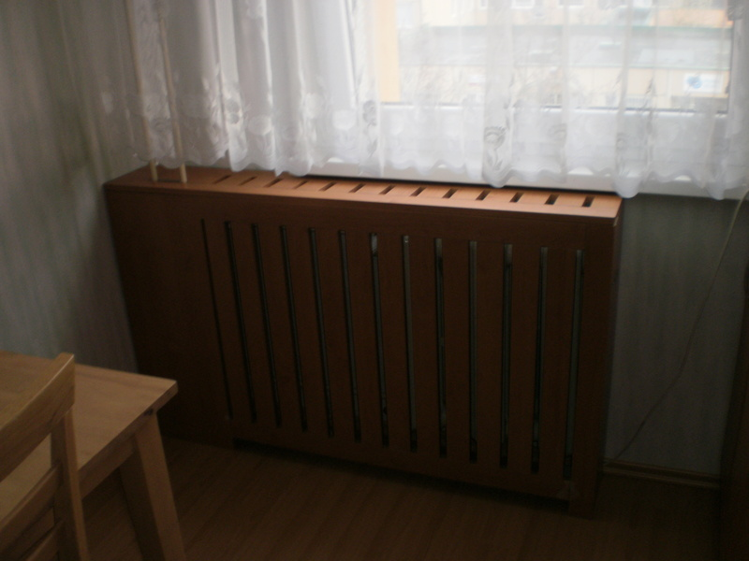](http://www.google.cz/url?sa=i&rct=j&q=&source=images&cd=&cad=rja&docid=r7K-g8Z26_A9tM&tbnid=ybEct8B4VW9BEM:&ved=0CAUQjRw&url=http://www.nejremeslnici.cz/reference/21590/fotka/43258-kryt-topeni-radiatoru&ei=3Z25Uahfw9C1Bv68gbAF&bvm=bv.47883778,d.Yms&psig=AFQjCNH4RvgRhDJZc-LT7oAe9Ac0HvxZOQ&ust=1371205345542182)

